|  |
| --- |
| **Church News**  radiYAte Weekend Away  Young adults weekend away is happening Sept 14-16! Our speaker is James Chen. Registrations still open!  Reachout Missions Conference (Sept 8-9 in Katoomba)  God calls all to partake in His great mission, whether you are looking to go short term/long term or still trying to figure out. ReachOut conference is a good way to learn more about missions and different opportunities available.  See PT (from Bankstown) if interested. You can also RSVP on Facebook: <https://www.facebook.com/events/457380904713427/>  Support Gospel work at SWEC!  Generous financial partners are needed to help grow the ministry of Gospel work at SWEC.  Please consider partnering with SWEC by setting up electronic giving.  For information on how to set this up, email [give@swec.org.au](mailto:give@swec.org.au) |

**Offertory Update**

|  |  |  |  |  |  |
| --- | --- | --- | --- | --- | --- |
| July | | | Year To Date | | |
| Actual | Budget | Difference | Actual | Budget | Difference |
| $34,914 | $38,554 | ($3,640) | $212,830 | $225,741 | ($12,911) |
|  |  |  |  |  |  |

|  |  |  |  |  |  |  |  |
| --- | --- | --- | --- | --- | --- | --- | --- |
| **Upcoming Events**  August  18th – RICE Rally | **Stay Connected**   |  |  | | --- | --- | |  | fb.com/swechurch | |  | @swechurch | |  | swec.org.au/newsletter | |

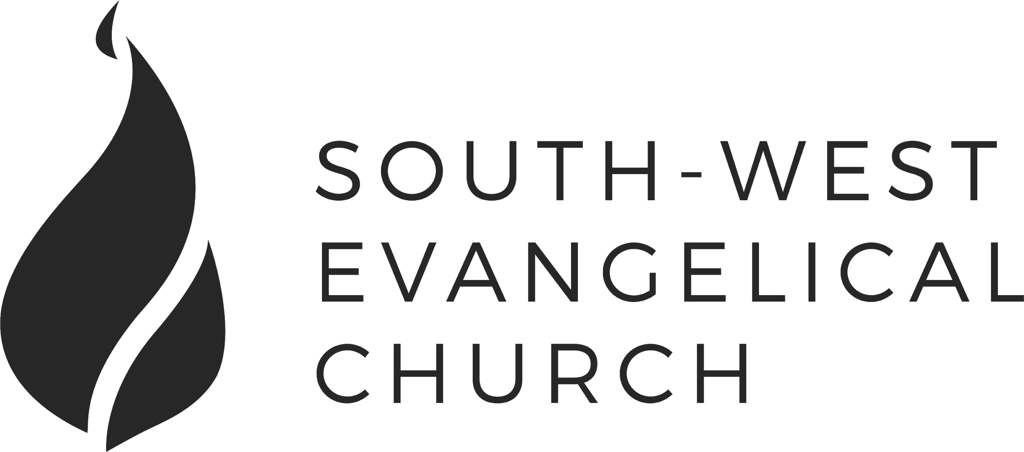

Sunday, 12 August 2018 | 11am English | [www.swec.org.au](http://www.swec.org.au)

Pastor Peter Ko | 0433 493 488 | pko@swec.org.au

What we’ll be doing during our time together

1. Worship

We’ll be worshipping God through song, prayer and by hearing His word.

Today’s confession prayer

Most merciful God,  
we humbly admit that we need your help.  
We confess that we have wandered from your way:  
We have done wrong, and we have failed to do what is right.  
You alone can save us.  
Have mercy on us:  
Wipe out our sins and teach us to forgive others.  
Bring forth in us the fruit of the Spirit  
That we may live as disciples of Christ.  
This we ask in the name of Jesus our Saviour.  
Amen.

Bible reading - 1 Samuel 3:1-5, 10-11

2. Community

An opportunity to get updated with what’s happening at SWEC!

3. Prayer

We’ll be praying for various needs in our church, the wider community, and the world.

4. God’s Word

Today’s sermon will be given by Andrew Hayes.

5. Response

An opportunity for us to respond by singing, through holy communion, and by financial giving.

6. Blessing & Sending  
Go with God’s blessing to love and serve him and the world.

|  |  |  |
| --- | --- | --- |
| **Pastors**  Peter Ko (Lead Pastor)  Stephen Fei  Dom Cheung  Karen Ko | **Elders**  Johnson Lee  Andrew Lim  Kirby Wong  Nelson Siu  board@swec.org.au | **Student Pastors**  Andrew Hayes  James Hoey  **Ministry Intern**  Lisa Truong |

Idolatry: It will kill you

1 Corinthians 9:24-10:14

Does it matter who and how you worship?

1. Examples: for us
2. Be careful: you could fall (Once saved always saved?)
3. The problem with idolatry

*Fear, flee, fight, find forgiveness.*

Today’s Sermon Code:

Zacpages is a digital church tool to follow our sermon outlines, read bible references, take notes and find out more information about our upcoming church events.

Check it out on the Apple App Store, or Google Play Store!

